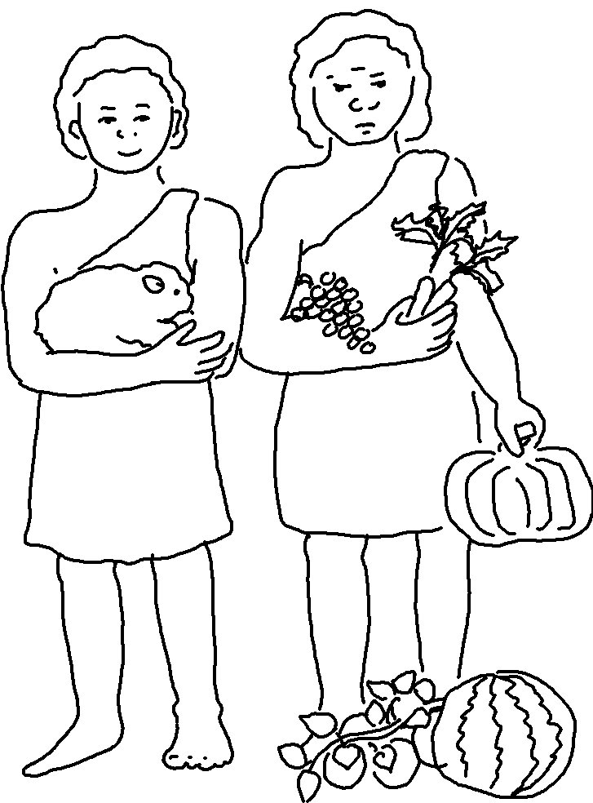
Do what is _ _ _ _ _ and _ _ _ _ in the Lord’s sight, so all will go well with you. Deuteronomy 6:18

